**Checklist Procedure  
for Instrumentation**

**Fork Detector Measurement System Software**

**Fork Detector Measurement System Software**

**December 2012**

|  |  |
| --- | --- |
| Preparation and Review: | ______________________________ |
| Review: | ______________________________  Manager, SGTS/TTR |
| Approval: | ______________________________ |

Contents

Installing FDMS with Radiation Review, Configuring a Facility 1

Checking FDMS for operational completeness 6

Files 6

COM Port Communications 6

Radiation Review integration 7

Check acquisition and collection status from MIC 7

Preparing unattended data for FDMS with Radiation Review 10

Importing Data into Radiation Review 10

Finding events in Radiation Review 15

Preparing Radiation Review measurement events for export to FDMS 23

Background events. 24

Exporting Radiation Review measurement events to FDMS 29

References 35

# Installing FDMS with Radiation Review, Configuring a Facility

Invoke the installer from physical media, (a CD), or an electronic distribution, per the instructions found in IRS Installation Guide6.

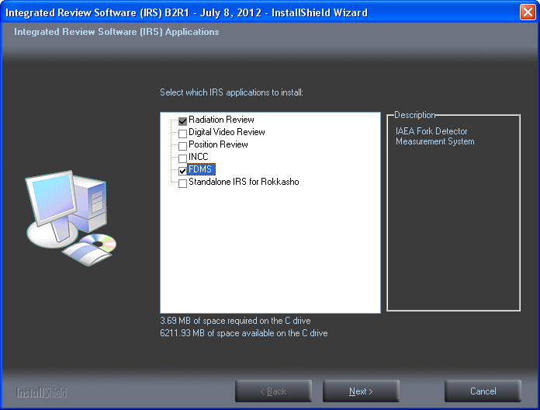

When prompted, create a new facility using the “Facility Manager’ tool.

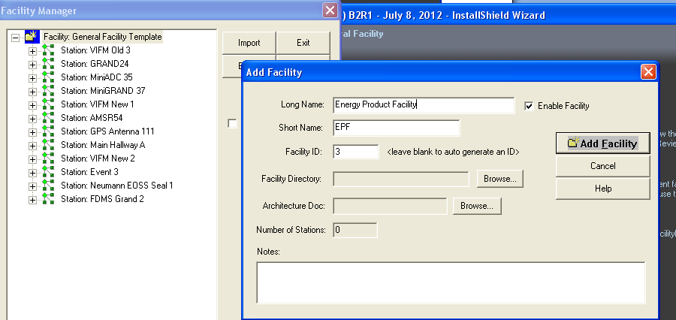

Within the “Facility Manager” tool, define one or more GRAND/MiniGRAND stations (instruments) with appropriate channel definitions, corresponding to the facility’s expected instrumentation. A facility expert at headquarters should provide or enter this information.

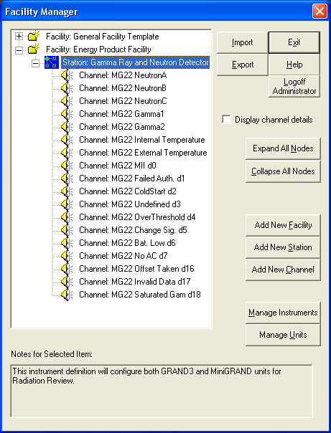

After creating the facility and exiting the installer and facility manager, go to the installation location and run the IRS “patcher” tool (See IRS Release Note11 § Aug. 7, 2010). Each tool installed (typically at least RAD and FDMS), will automatically run, forcing the creation of associated facility configuration assets on the installation machine.

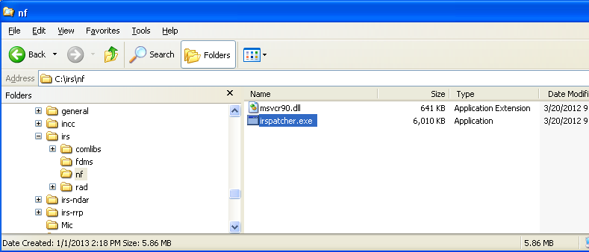

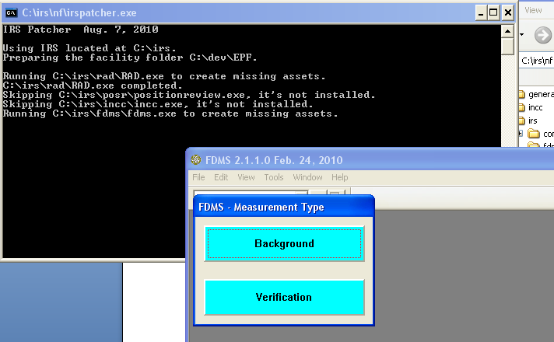

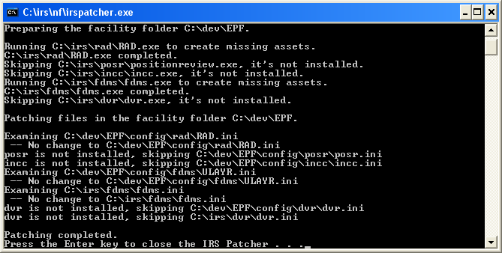

Location of FDMS facility config files

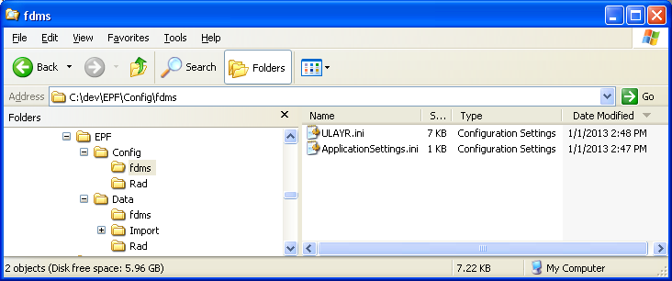

Location of FDMS M, MP and DB files

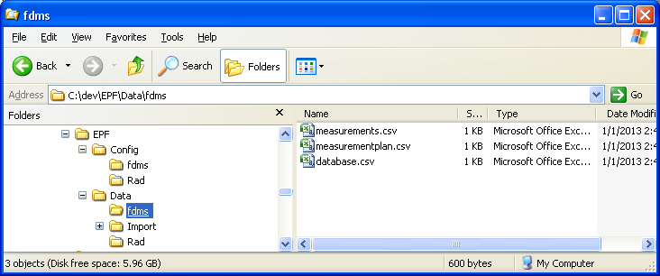

# Checking FDMS for operational completeness

## Files

FDMS must have available the csv files, that is, the ‘database’ (DB), Measurements (M) and Measurement plan (MP) files. The file content description for each file is found at *FDMS Reference Manual*7, *§ Data (MP, M, and DB) file format*, *page 14*.

The expected paths for these three files are found in the file FDMS.ini, found in the \irs\fdms installation folder. See the *FDMS Reference Manual*7, *page 8*, for details on the contents of the FDMS.ini file.

## COM Port Communications

For attended measurements, FDMS must have access to a COM port, and the COM port must be capable of standard serial communications with the miniGRAND electronics of the Fork Detector system.

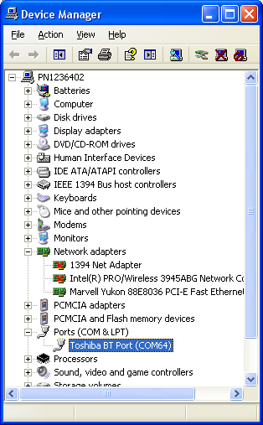

Figure 1 Port identification via the Windows Device Manager

Check and verify the settings in the FDMS.ini file under the [GRAND] section for correctness. The COM port definition there must match one of that shown in the Windows Device Manager Ports listing. See *MiniGRAND User Manual*13 and *Multi-Instrument Collect User’s Manual* 8 for full details on instrumentation configuration, diagnostics and use.

## Radiation Review integration

For unattended processing of miniGRAND data files, as collected by the MIC software, FDMS must have a properly defined facility configuration with correct miniGRAND instrumentation definitions.

Confirm the station id for the Fork Detector miniGRAND is correctly defined for the FDMS facility.

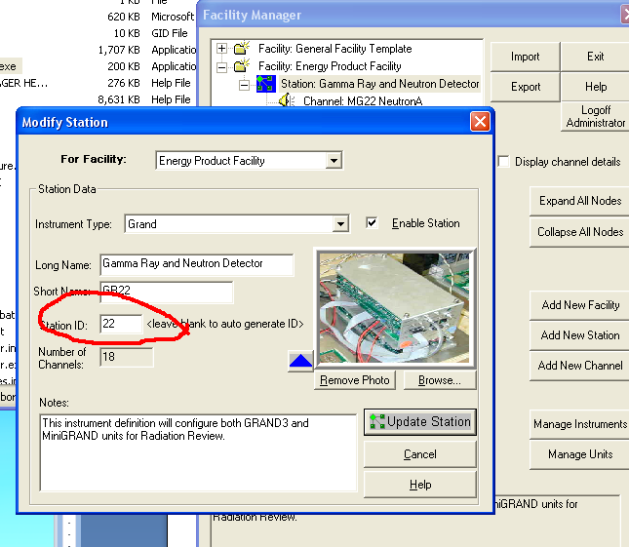

# Check acquisition and collection status from MIC

MIC collects data, unattended, from miniGRAND instrumentation, including Fork Detectors, for later review in Radiation Review and subsequent analysis in FDMS. This section is taken from the *Radiation Review Checklist Procedure*12

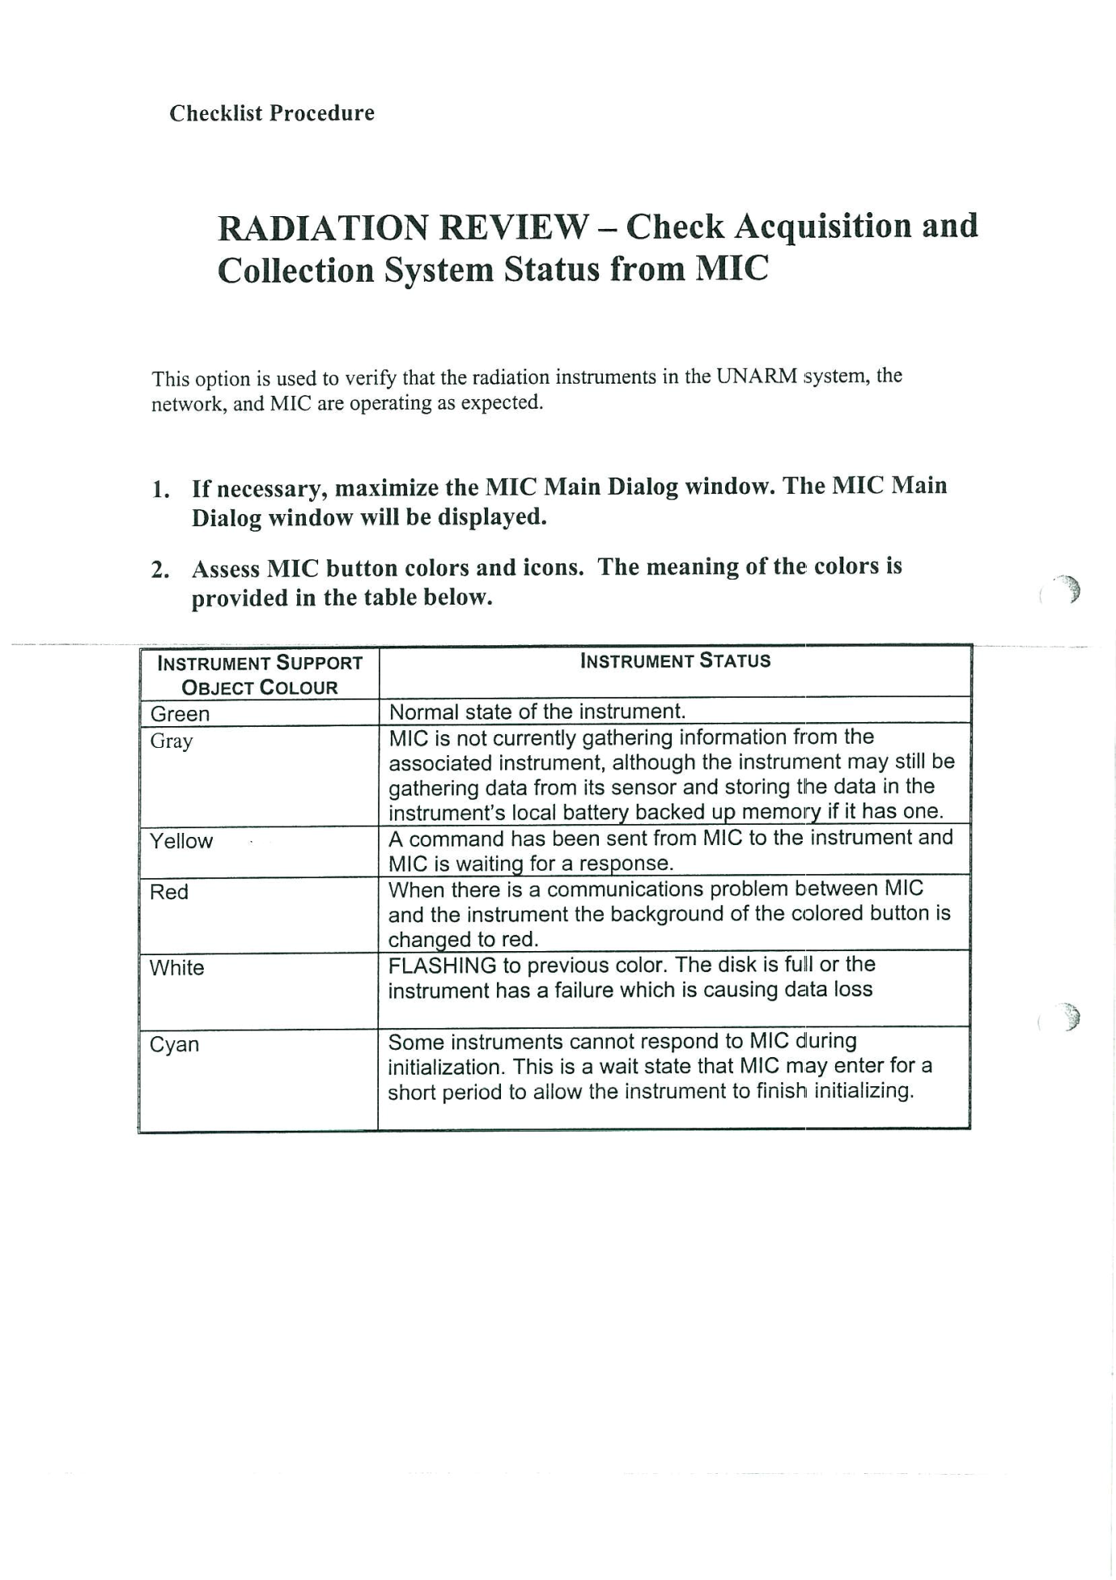

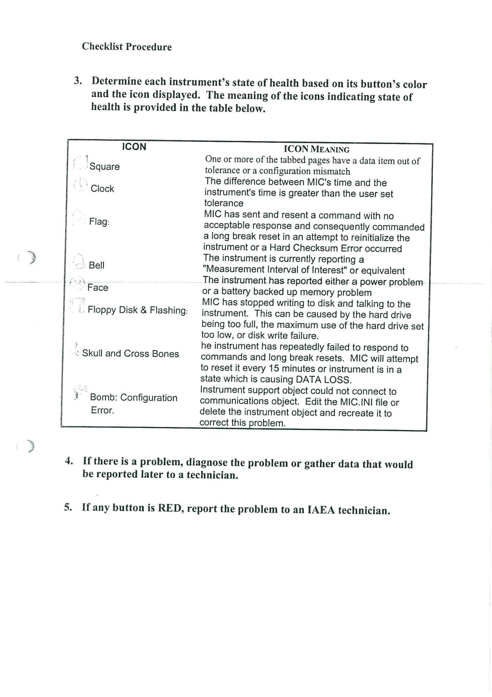

# Preparing unattended data for FDMS with Radiation Review

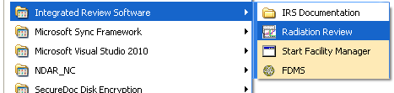

Figure 2 Starting Radiation Review from the Windows Start Menu

## Importing Data into Radiation Review

Raw measurement data is collected by unattended measurement acquisition software using GRAND and miniGRAND instruments. This raw data is initially available as .BID files. For more information on the data collection process, see *Multi-Instrument Collect User’s Manual* 8. This document is found on the B2R1 CD, under the Collect folder, and under C:\MIC after installing the MIC software..

To import .BID data files into RAD, select the “Import” menu item and then “Import All …”. See Figure 3.

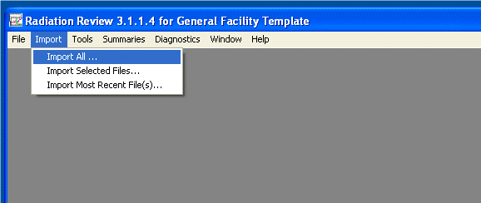

Figure 3 The Radiation Review “Import All …” Menu Item

A dialog appears (see Figure 4). Use this dialog to browse to the location of the BID files. Sample files are supplied with the ESP8 FDMS installation. They are found in the facility data folder for FDMS. For the rest of this document, these sample files are the source of data. Assume also for the purposes of illustration that the facility is named ‘general’ and the data and configuration folders and files for ‘general’ is installed at c:\general. The ESP 8 installation created this set of folders and files as part of the installation process.

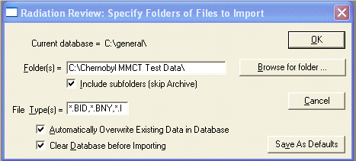

Figure 4 Import Folder Specification

Select the ‘Browse for folder …” button, and navigate to the supplied sample files, at “c:\general\data\fdms\BID Sample Data”. See Figure 5 and Figure 6.

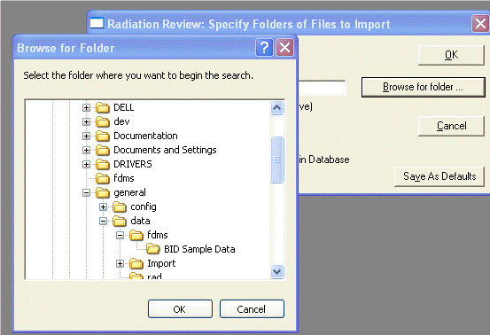

Figure 5 Browsing to the BID Sample Data Folder

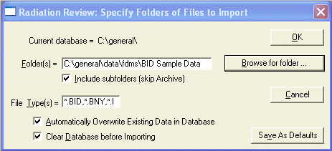

Figure 6 Import Parameters are Ready

If you have chosen to clear the database prior to the import operation, acknowledge the removal of preexisting data in the RAD database. See Figure 7.

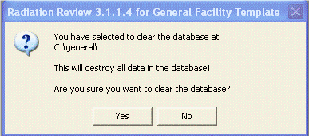

Figure 7 Affirming Database Clearing

The data import starts. RAD displays a progress bar and a textual display indicating the data importation progress. See Figure 8.

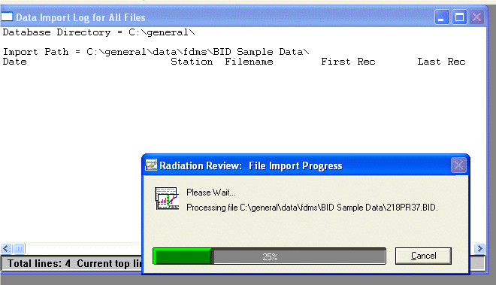

Figure 8 Radiation Review Data Import Progress

The results of the import operation are shown in Figure 9 below. In our example, two BID files were found with data from a MiniGRAND. Next, measurement events are determined from the imported data.

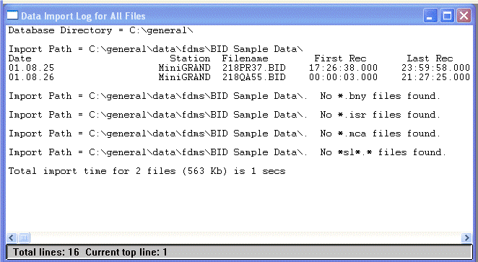

Figure 9 Radiation Review Data Import Log

## Finding events in Radiation Review

A review of the imported data is first made by using the RAD graph. Events corresponding to radiation peaks are quickly identified and characterized. Reviewing the data in this manner will provide an indication of the quality, number of events of interest, and strength of the measurements relative to the measured background radiation. From this review a minimal threshold for event detection may be determined. That value will be used in the next step.

Figure 10 shows how the RAD graph tool is invoked.

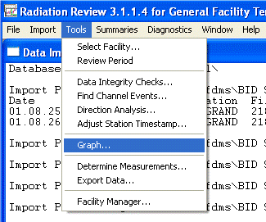

Figure 10 Radiation Review “Tools” “Graph…” Menu Item

Figure 11 below shows a time span of the data imported into RAD. Notice the easily discernible peaks in Neutron channels A and B, and Gamma channel 1. Also notice that Neutron channel C has no data, and the Gamma 2 data is useless noise.

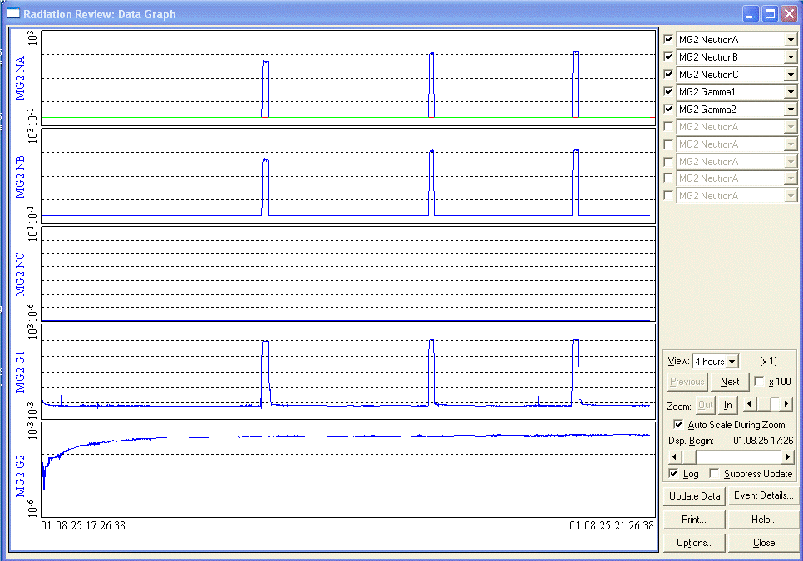

Figure 11 Graph View of Imported Data

Select a peak (See Figure 12) and determine a good value relative to the background for threshold detection. In this case, Neutron Channel A provides good data, and a review of the peaks shows that a value of about 20 up to 75 will give a strong indication of a radiation detection event. 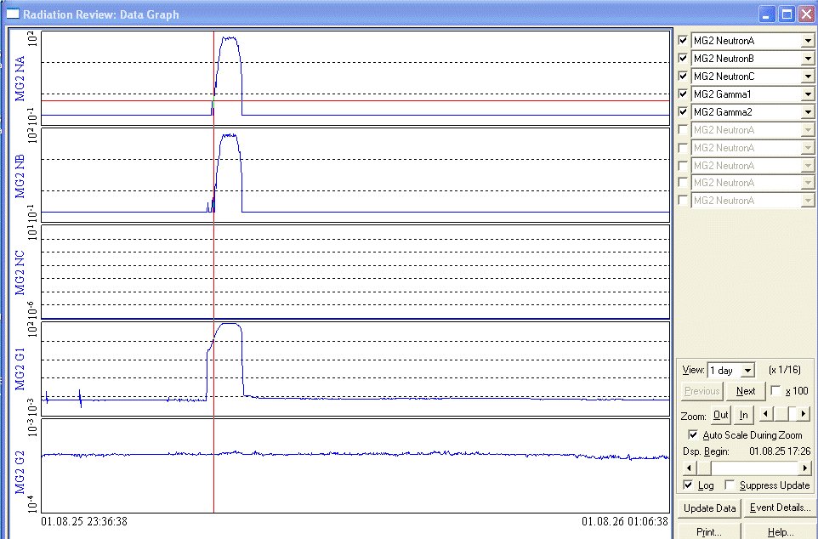

Figure 12 Examining a Radiation Peak on the Graph

With a good heuristic value for threshold detection at hand, start the ‘Find Channel Events’ operation by selecting the ‘Find Channel Events…’ menu item from the RAD ‘Tools’ menu. (Figure 13)

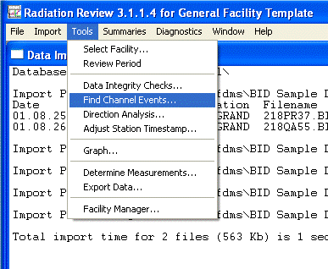

Figure 13 The “Find Channel Events…” Menu Item

The ‘Find Channel Events’ Parameters dialog (Figure 14) is used to specify the station and channels, and the threshold diction limits and technique for automatically detecting events in eh measurement data. In this example, we will scroll down the list of channels available in the RAD database to find the miniGRAND Neutron Channel A.

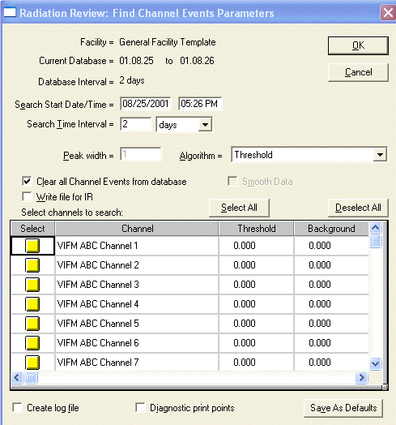

Figure 14 Choosing Channels to Analyze for Events

Here (Figure 15) MG2 NeutronA is selected. No other channels are selected. The detection threshold has been set at 25.00. Select “OK” to start threshold detection.

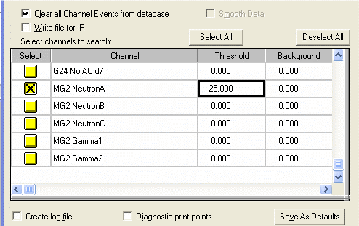

Figure 15 Selecting a Channel and Setting the Peak Threshold Value

The detection processing is displayed in Figure 16. The results show that 22 events were detected, as shown in Figure 17.

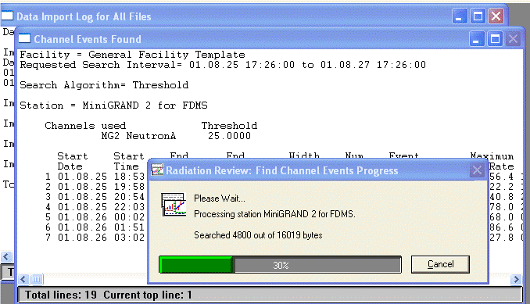

Figure 16 Threshold Detection Progress

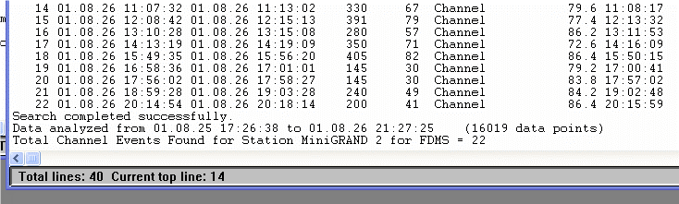

Figure 17 Threshold Detection Results

A review of the graph shows the detected events highlighted in pink in the A channel. It looks good. (Figure 18)

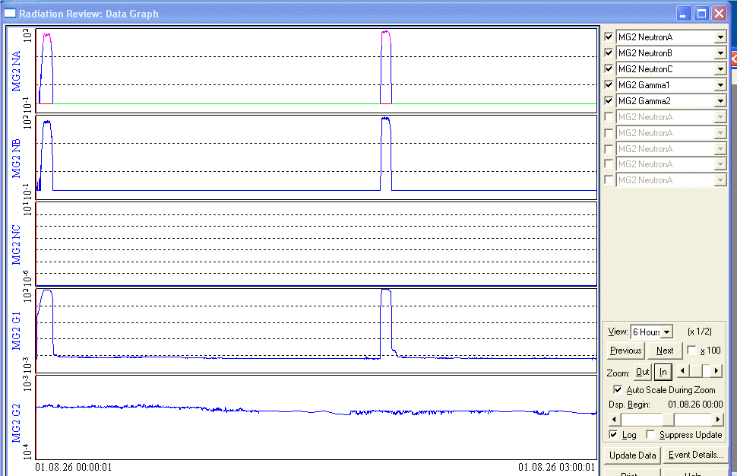

Figure 18 Reviewing the Marked Events in the Graph

## Preparing Radiation Review measurement events for export to FDMS

The detected events need to be identified with an ID that corresponds to the Assembly ID used by FDMS. In our example, IDs MIC-01 through MIC-22 will be used. Using the Event Details dialog, the event ID can be added. The event area can be modified, and the event type can be specified.

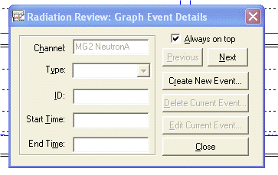

Figure 19 The Graph Event Details Dialog

Figure 20 shows an event selected, with the Event Details dialog ready for editing.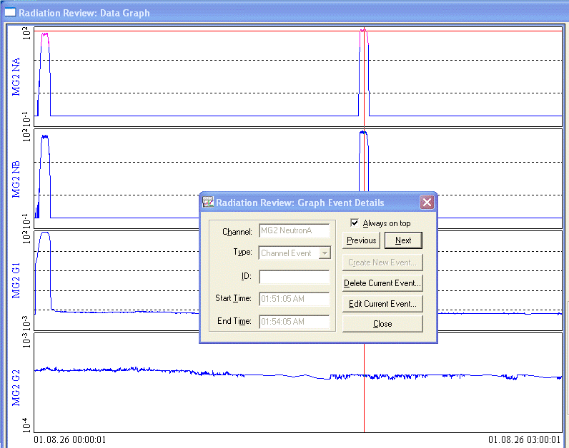

Figure 20 Editing an Event using the Graph Event Details Dialog

Background events.

New in RAD for this release is the creation of background events. FDMS can use a background measurement to adjust the results of a cycle or assembly measurement. The RAD Event Details dialog is used to create an event of type background. Select an arbitrary area of a graph, choose the Background Event type, and save the changes.

Figures 21 through 27 show the creation of a background event prior to the 5th event in the data. The event is created and the area adjusted to correspond only with background. The event is named BKG 5.

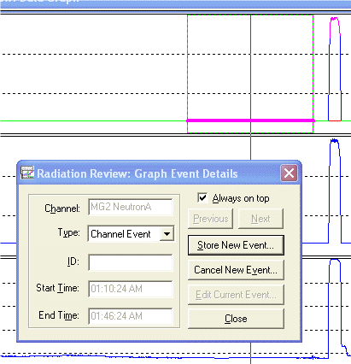

Figure 21 Marking an Area for a New Event.

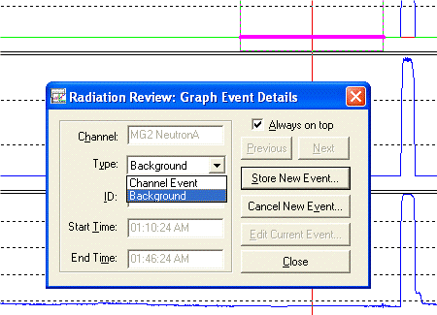

Figure 22 Setting the Background Event Type

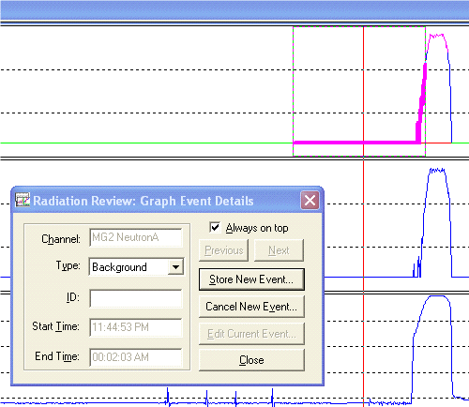

Figure 23 Adjusting the Area Selection

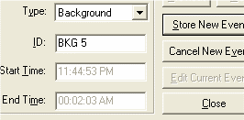

Figure 24 Give the Event the Name “BKG 5”

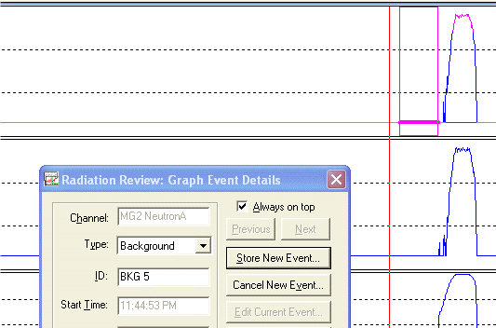

Figure 25 The Background Event “BKG 5” is ready

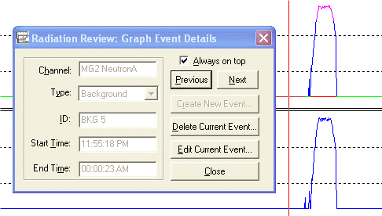

Figure 26 Background Event has been saved

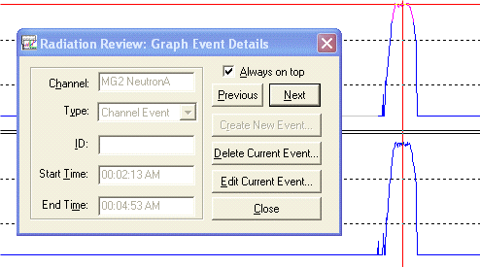

Figure 27 Move to the Next Channel Event

Additional background events can be created as necessary. During the import processing of FDMS, multiple background measurements can be used. When a measurement is analyzed the background measurement corresponding to the closest in time is used in the analysis.

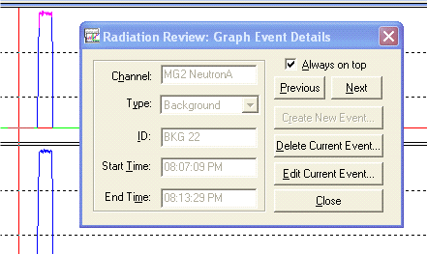

Figure 28 Another Background Event

## Exporting Radiation Review measurement events to FDMS

After events have been identified, edited and marked, the events may be exported for use by FDMS. A shared file is created detailing the chosen events. FDMS refers to this file during the import process. To export from RAD, open the Export Data dialog from the ‘Tools’ ‘Export Data…’ menu item.

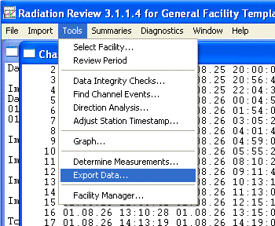

Figure 29 The “Tools” “Export Data…” Menu Item

In the “Export Data” dialog, you select the types of measurements to export, and the stations or detectors that are the source of the events. FDMS uses the “Write XML file” export option. INCC uses the “Write NCC files” option, and Integrated Review uses the “Write IR file” option.

For FDMS, (see Figure 31)

1. Choose both Static Background and Channel Event to export.
2. Make sure that the “Write XML file” option is selected.
3. Select the detector that corresponds to the events that were identified in the previous steps.
4. Select OK to export.

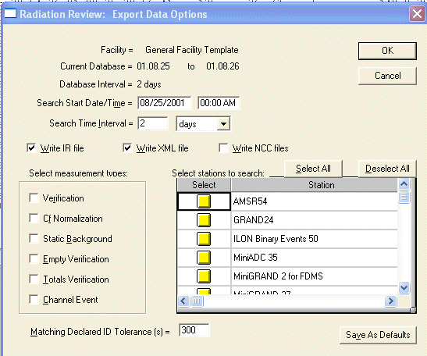

Figure 30 The Export Data Options Dialog

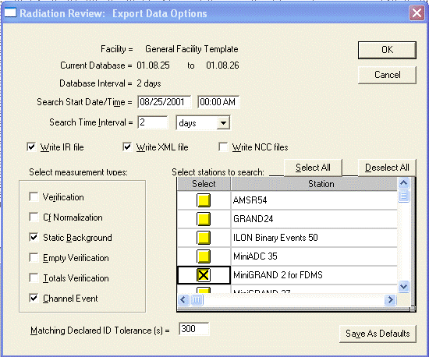

Figure 31 Selecting Background and Channel Events for a Channel

After selecting ‘OK’, a new dialog with a list of all Background and Channel events is presented in an editable tabular format. Here you may enter the unique Assembly IDs corresponding to each measurement event of interest. Select ‘OK’ to create the external XML file used by FDMS to obtain the specified event data for analysis. Figure 31, Figure 32, and Figure 33 show the editing process. Figure 34 show the progress indicator during the export processing.

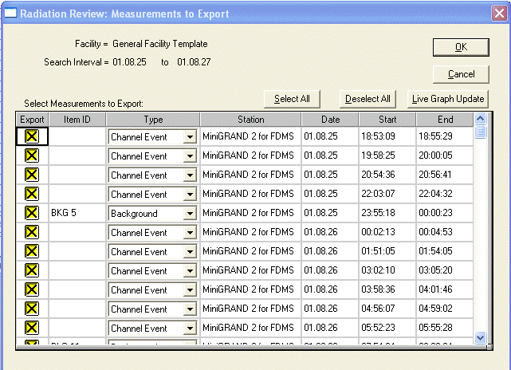

Figure 32 The Table of Events to Export

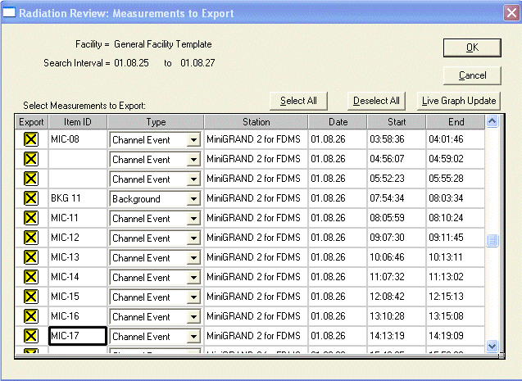

Figure 33 Editing Individual Events

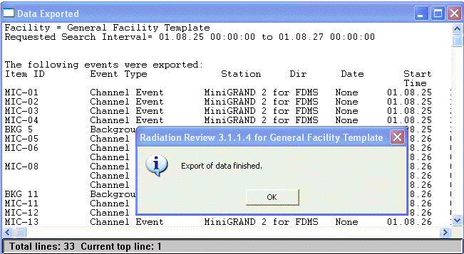

Figure 34 Data Export Results

A log similar to this example is made during the export processing.

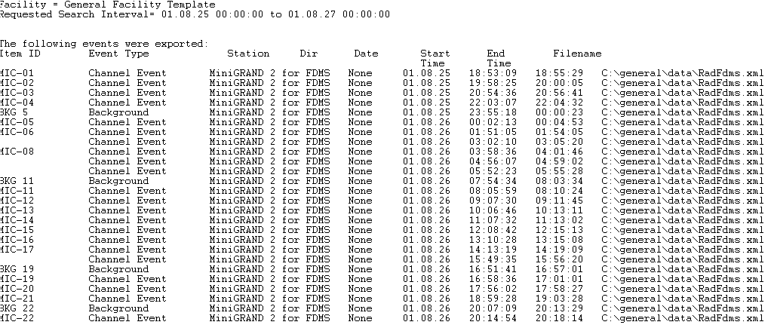

Figure 35 Data Export Summary Log

# References

1. J. Longo et al., *Fork Detector Measurement Software (Version 2.1.1.0)* LA-CC-03-02 (Feb. 24, 2010)*, packaged within* Integrated Review Software, LA-CC-10-095 (July 8, 2012).
2. J. Lestone, J. Longo, *Fork Detector Measurement Software User Guide (Version 2.1.1.0),* Safeguards Science and Technology Group N-1, Los Alamos National Laboratory, LA-UR-05-9043 (December 1, 2005).
3. J. Longo, *Quick User Instructions for FDMS 2.0. A Description of the New Unattended Measurement Features of the Fork Detector Measurement System,* Safeguards Science and Technology Group N-1, Los Alamos National Laboratory (March 12, 2005).
4. J. Lestone, J. Longo, *Fork Detector Measurement System (FDMS), Quick User Instructions for the Second Field Testable Version of the Software (Version 1.02),* Safeguards Science and Technology Group NIS-5, Los Alamos National Laboratory (November 7, 2003).
5. S. Klosterbuer, *Radiation* *Review User Manual,* Safeguards Science and Technology Group N-1, Los Alamos National Laboratory report LA-UR-99-1965 (December 1, 2004).
6. S. Klosterbuer, H. Nordquist, *Integrated Review Software Installation Manual,* Safeguards Science and Technology Group N-1, Los Alamos National Laboratory report LA-UR-04-8626 (February 25, 2005).
7. J. Longo, J. Lestone, *Reference Manual for Instrumentation, Fork Detector Measurement System*, Software Safeguards Science and Technology Group NEN-1, Los Alamos National Laboratory report LA-UR 13-20601 (Jan. 23, 2013).
8. D. Pelowitz, P. Moore, T. Wenz, J. Longo, W. Hansen, *Multi-Instrument Collect User’s Manual*,Safeguards Science and Technology Group NEN-1, Los Alamos National Laboratory report LA-UR-13-20425 (July 8, 2012).
9. J. Longo, et al., *Unattended and Remote Monitoring Software Baseline 2 Revision 1*,Safeguards Science and Technology Group NEN-1, Los Alamos National Laboratory LA-CC 10-095, (Jan. 23, 2013).
10. J. Longo, *B2R1 Version Description Document, Revision 18*, Safeguards Science and Technology Group NEN-1, Los Alamos National Laboratory report LA-UR-13-20424, (Jan. 23, 2013).
11. J. Longo, J. Montoya, *B2R1 IRS Installer Release Note*, Safeguards Science and Technology Group NEN-1, Los Alamos National Laboratory report LA-UR 10-6377 (rev. July 8, 2012).
12. C. Carroll, *Checklist Procedure for Instrumentation, Radiation Review*, Division of Technical Support, Department of Safeguards, IAEA, (Apr. 2005).
13. R. Parker and S. Klosterbuer, *MiniGRAND User Manual* (01.12), Safeguards Science and Technology Group N-1, Los Alamos National Laboratory report LA-UR-05-7643 (Feb. 2008).